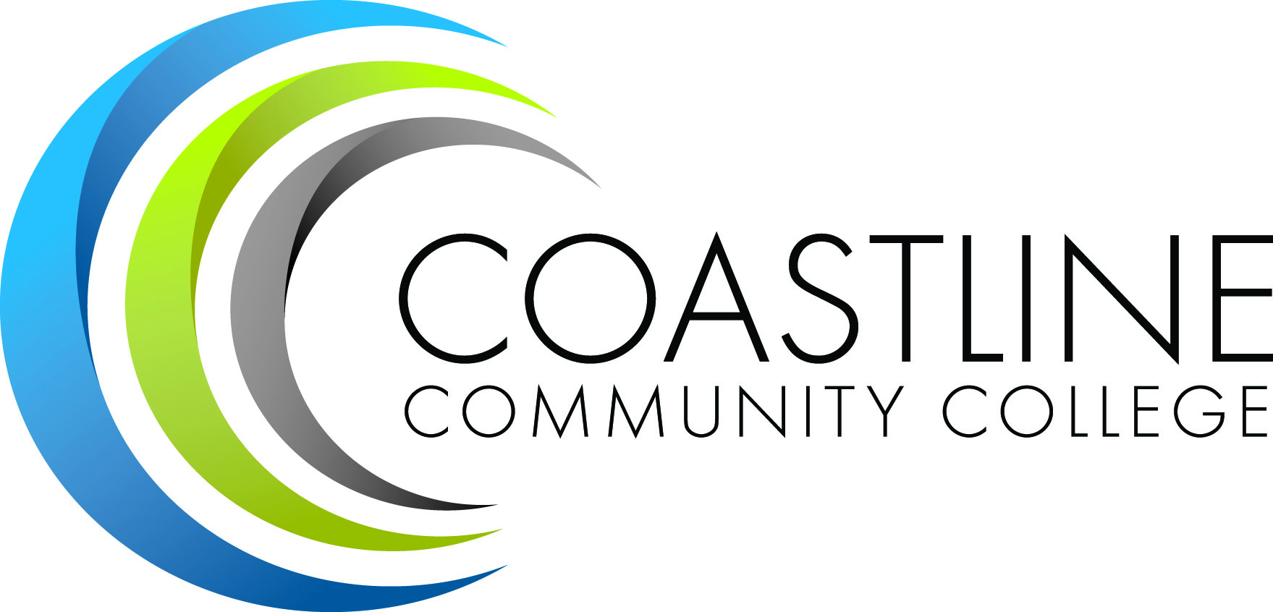

DRAFT

Program/Department Review Handbook

  - Approved by Academic Senate:

Table of Contents
Principles of Program/Department Review…………………………………………….…………………………………3
Program/Department Review Process……………………………………………………………………………………….4
Academic Program Review Template Narrative……………………..……………………………….…………..…….7
Department Review Template Narrative…………………………………………………………………………………11

Principles of Program/Department Review
Program and department quality and improvement are the primary focus of Program/Department Review. Five Year Annual in-depth reviews and yearly update reviews are conducted to assess relevance, appropriateness, student learning outcomes, department service outcomes, currency of curriculum and support services, and to identify future needs and plans.
Program/Department Review is an ongoing process that includes:
- Review and description of the program's/department’s mission and current state of the program/department
- Evaluation of whether the program/department as it exists is adequate and appropriate for achieving its and the college’s mission and assuring student success
- Development of goals and plans for any improvements or changes that will enhance student learning outcomes and overall program/department efficiency
- Implementation of plans
- Tracking and evaluation of actions taken to improve program/department effectiveness and efficiency

- Accreditation Standard II.A.2. The institution assures the quality and improvement of all instructional courses and programs offered in the name of the institution, including collegiate, developmental, and pre-collegiate courses and programs, contract and community education, study abroad, short-term training courses and programs, programs for international students, and other special programs, regardless of type of credit awarded, delivery mode or location .

Program/Department Review Process
Planning-The Education Master Plan goals and objectives are sent to programs and departments at the beginning of each spring semester (see figure #3). During this time, discussions can take place to review the current plans and directions of the program/department and provide ample time to restructure programs and design/redesign curriculum and programs to address these objectives and goals. By reviewing and addressing these goals prior to beginning the program review cycle, the goals and objectives become completely integrated into the program review.
Data Gathering-The program/department review actually begins the spring semester of the Program Review Preparation year and includes documentation of evidence; needs assessments; curriculum updates; surveys of students, faculty, staff, and administrators; business and industry partner advisory comments and recommendations; review of Program/Course Student Learning Outcomes; assessment and revision; facility needs; staffing needs; and any additional items that could potentially require resource allocation. Student Learning Outcomes, Program Student Learning Outcomes and Institutional Student Learning Outcomes (SLOs, PSLOs, ISLOs) will be collected at the end of each fall semester by all disciplines, whether they are going through the full program review cycle or the annual cycle. The outcomes from the student assessment will be discussed by the discipline faculty at the spring faculty meeting. Discussions will center on student achievement of SLOs/PSLOs/ISLOs as they relate to the Education Master Plan goals, and adjustment to these goals and outcomes will be made to ensure student success.
Writing Phase-During the fall semester following the program review preparation semester, the program/department prepares its Review Report, outlining the findings from the data gathering cycle, reviewing the current structure and goals, and then preparing an action plan and resource allocation predictions for both the following year and the next five years. Each of these planning documents should link to a specific Master Plan objective or goal with justification for resource allocation needs. As part of the writing phase, evaluation of the program/department review process should be assessed in terms of relevance, efficiency, and ways to improve the process, thus providing a true reflection of the process. A final copy of the Program/Department Review Report shall be submitted to the Instructional Dean or Department Manager for inclusion in Wing planning and budgetary request preparation.

Figure #3
Program Review Process

Presentation-During the fall semester following the program review preparation semester, the program/department delivers a presentation to the Program/Department Review Committee, outlining its review of its current structure and goals as well as the new five-year goals and objectives. These new goals and objectives as well as the planning documents developed during the writing phase are presented, showing links to the Education Master Plan. A summary of these reports is presented as an informational item to the Academic Senate, Classified Senate, and Blue Ribbon Management Team so that every constituency group is aware of the resource needs of programs/departments as presented in program review and will be better prepared for budget and resource allocation discussions.

Annual Report-For those programs/departments not engaged in the five-year Program Review Cycle, an action and resource allocation plan showing any needs that may require funding from the budgetary process and the justification based on the Education Master Plan Objectives will be submitted to the Program Review Committee by the end of the fall semester and then forwarded to the PIEAC for consideration of funding during the budget development discussions. A copy of the action and resource allocation plan shall also be given to the Wing managers. Major topics of interest to the entire college shall be considered for further vetting through various avenues including brown bag lunches and town hall gatherings.
Data Passed to Planning-By the last day of the fall semester, all Annual Resource Plans and Allocation Predictions and Five-Year Resource Plans and Allocation Predictions will be sent to College Council for review and then housed in the Office of Instruction with a copy being presented to the Chair of Planning, Institutional Effectiveness and Accreditation Committee (PIEAC) for use in discussions and planning prior to sending resource requests to the Budget Committee.

Academic Program Review Template Narrative
Programs that offer credit and non-credit courses will complete a self-evaluation of the program every five years. The report consists of six elements including: Executive Summary, Process, Description, Course Data, Program Outcomes, and Goals.
- Executive Summary
  - One-page summary that concisely describes the program, enrollment trends, accomplishments, and primary issues. Conclude the summary by succinctly listing the program’s new five-year goals.
- Process
  - Name of team leader
  - Names and titles of other team members
  - Who and how many people in each constituency group were surveyed and how many responded
  - Other data the team reviewed
  - Brief statement of how curriculum was reviewed
  - How expected SLOs were identified and measured
- Description
  - Overview
    - Discuss relevant historical information
    - Description of the current program
      - Purpose
      - Scope
      - Class locations
      - Delivery methods
      - Staffing
  - Certificate Requirements
    - Describe the focus of each certificate option
    - List the course requirements/units required for each certificate
    - If the program has no certificates, delete this section
  - Curriculum Review
    - All curriculum should be reviewed in the year prior to or during the Program Review.
    - Provide a brief summary of the process used by faculty to review the curriculum.
    - Complete and include the Curriculum Review form
      - Dates of the most recent revisions
      - The date on which the Curriculum Committee approved revised courses with robust student learning outcomes or the date on which the outline will go to Curriculum Committee.
      - If any courses were deleted or suspended, show the date on which that action occurred.
      - Discuss the overall adequacy of the curriculum
  - Need-Discuss the level of need for the program in the communities the college serves and among different student populations.
    - Labor market data
    - Reasons students indicate they are taking classes in the program
    - Enrollment patterns and/or projections
    - Availability of similar programs from other educational providers
    - Also note if courses in this program result in a certificate of completion or achievement, are part of a certificate in another program, or satisfy general education requirements.
  - Resources
    - Describe how items are used by the program and the extent to which they meet program needs.
    - Facilities
    - Equipment
    - Technology-discuss how technology is used to deliver or enhance instruction
    - Staffing- full-time/part-time faculty, support staff, etc.
    - Satisfaction-discuss student and faculty satisfaction with resources and course delivery technologies.
    - Needs
  - Professional Development
- Program’s expectations for professional development by faculty and staff and the extent to which faculty and staff engage in professional development activities.
- Address the types of activities pursued by faculty and staff
- How the program supports professional development
- Degrees, certificates, honors, and awards received by faculty and staff. Use faculty/staff surveys to collect some of this data.
- Professional development needs that are apparent

- Course Data
  - Include and analyze data
    - Enrollments/FTES
    - Sections
    - Cancellations
    - Average class size
    - Attrition
    - Enrollment trends
    - Site-based/distance learning ratio, et
  - Student Elements
    - Include and analyze data related to student characteristics
      - Age
      - Gender
      - Ethnicity
      - Employment status
      - Other colleges students attend
      - Military enrollments
      - Incarcerated
  - Cost Data
    - Full-time and part-time faculty costs for most recent year or semester
    - Support staff costs
    - Special facilities costs
    - Equipment
    - Supplies, etc. for most recent year.
    - Provide analysis of adequacy of funding and/or identify additional needs.
- Program Outcomes
  - Student Learning Outcomes
    - Provide narrative to discuss the process used by faculty in identifying expected course and program- level outcomes and in deciding how to measure learning outcomes.
    - Discuss progress in mapping course and program learning outcomes to college core degree-level outcomes.
    - Succinctly summarize and analyze actual student learning outcomes and recommendations to improve future outcomes.
    - If you want to provide detail, consider including the printout of SLO Progress Notes in the Appendix; redact CRNs and instructor names from the SLO Progress Notes.
  - Other Student Outcomes
    - Report and analyze other relevant outcomes
      - Course success as measured by grade distribution and course completions
      - Number of program graduates (certificates or degrees)
      - Number of students who transfer (if data is available)
      - Any alumni feedback regarding extent to which course work prepared them for higher-level courses or degrees or employment
  - Student Satisfaction
    - Discuss and analyze student satisfaction with quality of instruction
    - Variety of classes
    - Overall program quality
    - Extent to which faculty/staff meet the needs of culturally-diverse or non-traditional students
    - Other factors particularly relevant to the program.
  - Conclusions
    - Provide a brief overall summary of the program’s strengths
    - Areas that need improvement; include any inferences or conclusions that can be drawn from data gathered during the review
  - Recommendations
    - Recommendations for strengthening the program. Recommendations are generally things the program is dependent upon someone else in order to accomplish (e.g., related to facilities, staffing, marketing support, or budget issues outside the direct control of the program.
- Goals
  - Progress on Prior Goals
    - List goals and recommendations from the prior review of the program
    - Indicate what progress has been made on addressing those items
  - Self-Review Goals
    - List your new goals
    - Make the goals reasonable since you will be reporting progress on the Annual Institutional Planning report
    - These goals should be your goals to meet your recommendations that you found through your self-evaluation
  - Steering Committee Recommendations
    - These are developed as a response to your program review document by the Program Review Committee
    - Keep track of these recommendations since you should include address them as part of your Annual Institutional Planning report
  - New Five Year Goals
    - List new five-year goals for the program;
    - Target dates for completion
    - Identify approximate cost for items that will require new money

Department Service Review Template

Departments or Offices that do not have instructional contact with students will complete an annual Department Service Review. The report consist of seven elements (Description of the department, Department Mission, Service Area Outcomes, Status, Goals, Assessment Recommendations, and Additional Information)
- Description of the Department
  - Title/name
  - What your unit does
  - Where you're located
  - How you're staffed (positions and hours)
  - Resources
  - How you're funded (general fund, grants, categorical, etc.)

- Mission of your Unit
  - Mission Statement for the Department

- Stakeholders/Constituents
  - Faculty
    - Part-time Headcount FTES / LHE
    - Full-time Headcount FTES / LHE
  - Students (and subset)
  - Classified
  - Management
  - Community groups/partners/advisory groups
  - Other

- Service Area Outcomes/Learning Service Outcomes/PLOs/ILOs
Use the attached worksheet to identify the Service Area Outcomes for your unit. Outcomes relate to the standards you have for your unit. Generally, you will want to identify only two to four expected outcomes, so think in terms of the big picture rather than tiny pieces. For example, if emergency response planning is in your area of responsibility, instead of listing multiple small tasks (1. Write plan. 2. Revise plan annually. 3. Design training for faculty and staff. 4. Conduct training. 5. Evaluate training. 6. Conduct drills. etc.), create one "robust" outcome statement that conveys the big picture: Ensure that the college has an effective emergency notification and response system that maximizes the safety of students, faculty, and staff.

List your expected Service Area Outcomes in the first column of the DSR Assessment document. In the second column, identify your plans for assessing your unit's performance on the outcome: How will you measure success? When? Who? The third and fourth columns should be left blank during your initial planning. After you've assessed performance, you'll put the assessment results in the third column of the form and then use the fourth column to identify plans for improving performance.

- Status (Current status of the Department)
  - Strengths
  - Areas for Improvements
  - Opportunities - List potential opportunities that your department could take advantage of to help achieve its mission.
  - Implications for Planning and Budgeting - List any issues that will need to be addressed through college planning and budgeting processes; e.g., human, fiscal, and/or physical resources
- Goals - List the unit's primary goals and identify in parentheses the Master Plan Initiative (if applicable) that each goal supports.

Status of existing on prior goals
1.
2.
3.

New goals - New goals are new things you want or need to do either in terms of expanding or improving services. Include a target date for completing each goal.
1.
2.
3.

- Assessment Methods - Make notes here about the assessment tools and methods that you will need; e.g.,
  - Types of information you might want to gather
  - Suggested questions to include on surveys
  - Suggestions for who to survey

- Additional Information - Use this section to include additional information relative to the review or to upload documents that support the report; e.g., survey results, reports related to the use of outcomes assessments, etc.

- Goals - List the unit's primary goals and identify in parentheses the Master Plan Initiative (if applicable) that each goal supports.

Status of existing on prior goals
1.
2.
3.

New goals - New goals are new things you want or need to do either in terms of expanding or improving services. Include a target date for completing each goal.
1.
2.
3.

- Assessment Methods - Make notes here about the assessment tools and methods that you will need; e.g.,
  - Types of information you might want to gather
  - Suggested questions to include on surveys
  - Suggestions for who to survey

- Additional Information - Use this section to include additional information relative to the review or to upload documents that support the report; e.g., survey results, reports related to the use of outcomes assessments, etc.

- Goals - List the unit's primary goals and identify in parentheses the Master Plan Initiative (if applicable) that each goal supports.

Status of existing on prior goals
1.
2.
3.

New goals - New goals are new things you want or need to do either in terms of expanding or improving services. Include a target date for completing each goal.
1.
2.
3.

- Assessment Methods - Make notes here about the assessment tools and methods that you will need; e.g.,
  - Types of information you might want to gather
  - Suggested questions to include on surveys
  - Suggestions for who to survey

- Additional Information - Use this section to include additional information relative to the review or to upload documents that support the report; e.g., survey results, reports related to the use of outcomes assessments, etc.

